**Amrita Vishwa Vidyapeetham**

**Amrita School of Engineering, Coimbatore**

**Department of Computer Science and Engineering**

**Topic: Basic ALU Implementation using iVerilog**

**--------------------------------------------------------------------------------------------------------------------------**

**Sub Code: 19CS211 Sub Title: COA**

**Roll No: CB.EN.U4CSE19453 Name: R.ABHINAV**

**Lab Evaluation No: 3 Date: 01-03-2021**

1. Design of 1 bit ALU with the following operations

**iVerilog Code:**

module alu(a, b, op, out);

input a, b;

input[2:0] op;

output out;

reg out;

always@(a or b or op)

begin

case(op)

3'b000: out=a+b;

3'b001: out=a-b;

3'b010: out=(a & b);

3'b011: out=(a | b);

3'b100: out=!a;

3'b101: out=!(a & b);

3'b110: out=!(a | b);

3'b111: out=0;

endcase

end

endmodule

**TestBench :**

module alu_tb;

reg t_a, t_b;

reg [2:0] t_op;

wire t_out;

alu my_alu(.op(t_op),.a(t_a),.b(t_b),.out(t_out));

initial

begin

$monitor(t_a, t_b, t_out);

t_a=1;

t_b=0;

t_op=3'b000;

#10

t_a=1;

t_b=0;

t_op=3'b001;

#10

t_a=1;

t_b=0;

t_op=3'b010;

#10

t_a=1;

t_b=0;

t_op=3'b011;

#10

t_a=1;

t_b=0;

t_op=3'b100;

#10

t_a=1;

t_b=0;

t_op=3'b101;

#10

t_a=1;

t_b=0;

t_op=3'b110;

#10

t_a=1;

t_b=0;

t_op=3'b111;

end

endmodule

**Output :**

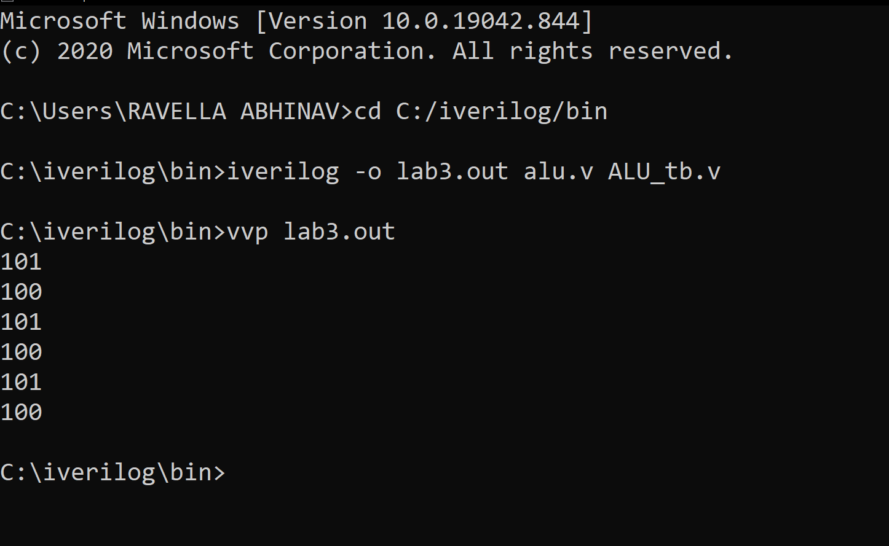

**Code Snippets :**

